SET 5: Website Analytics
Task 1: Line Chart (Daily Page Views)
Procedure
- Open Tableau Desktop.
- Connect to the Website Traffic Excel dataset.
- Open Sheet 1.
- Drag Date to Columns.
- Drag Page Views to Rows.
- Tableau automatically creates a Line Chart.
- Rename the chart title to Daily Page Views Trend.
- Rename the X-axis as Date.
- Rename the Y-axis as Page Views.
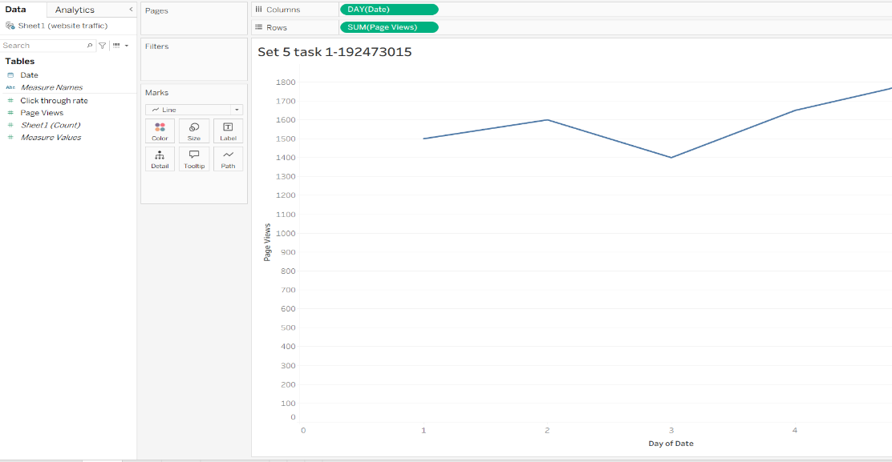

Task 2: Bar Chart (Top Click-through Rate)
Procedure
- Click New Worksheet (+).
- Drag Date to Columns.
- Drag Click-through Rate to Rows.
- Choose Bar Chart from Show Me.
- Click the Sort Descending icon to display the highest click-through rate first.
- Add Click-through Rate to Label.
- Rename the chart title as Top Click-through Rates.
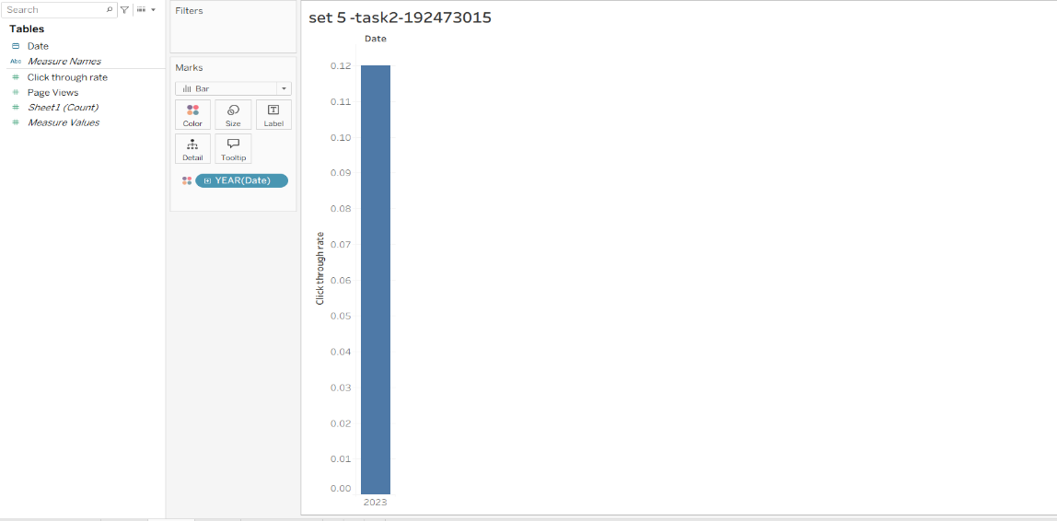

Task 3: Stacked Area Chart (Likes, Shares, Comments)
Note: Your dataset contains only Date, Page Views, and Click-through Rate. There are no Likes, Shares, or Comments columns. Add these columns in Excel before creating this chart.
Procedure
- Open a New Worksheet.
- Drag Date to Columns.
- Drag Measure Values to Rows.
- Drag Measure Names to Color.
- Filter Measure Names and select only:
  - Likes
  - Shares
  - Comments
- On the Marks card, change the chart type to Area.
- Tableau creates a Stacked Area Chart.
- Rename the title as User Interaction Distribution.

Task 4: Dashboard
Procedure
- Click the New Dashboard icon.
- Drag the Line Chart to the dashboard.
- Drag the Bar Chart beside it.
- Click the ▼ on the Line Chart → Use as Filter.
- Show the dashboard title.
- Rename it as Website Analytics Dashboard.
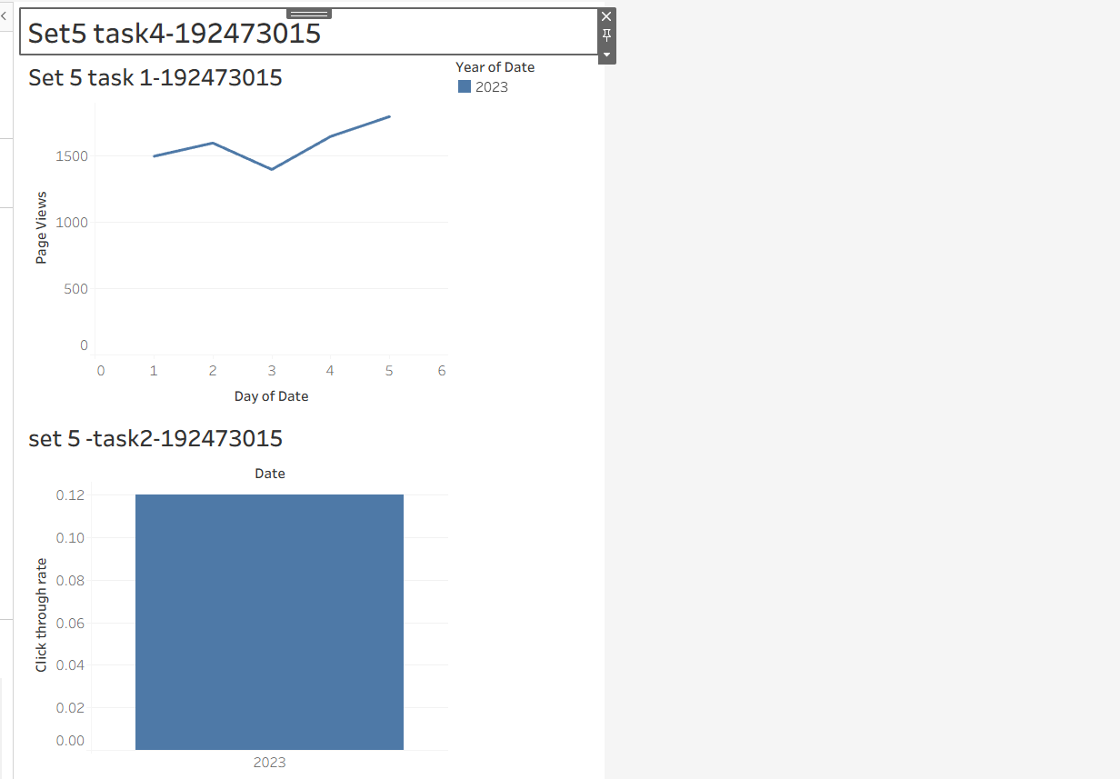
- Save the workbook.

SET 6: Product Sales Analysis
Task 1: Grouped Bar Chart
Procedure
- Connect to the Monthly Product Sales dataset.
- Open Sheet 1.
- Select the columns January Sales, February Sales, and March Sales.
- Right-click and choose Pivot (if your data is in separate month columns).
- Rename:
  - Pivot Field Names → Month
  - Pivot Field Values → Sales
- Drag Month to Columns.
- Drag Sales to Rows.
- Drag Product Name to Color.
- Choose Bar Chart from Show Me.
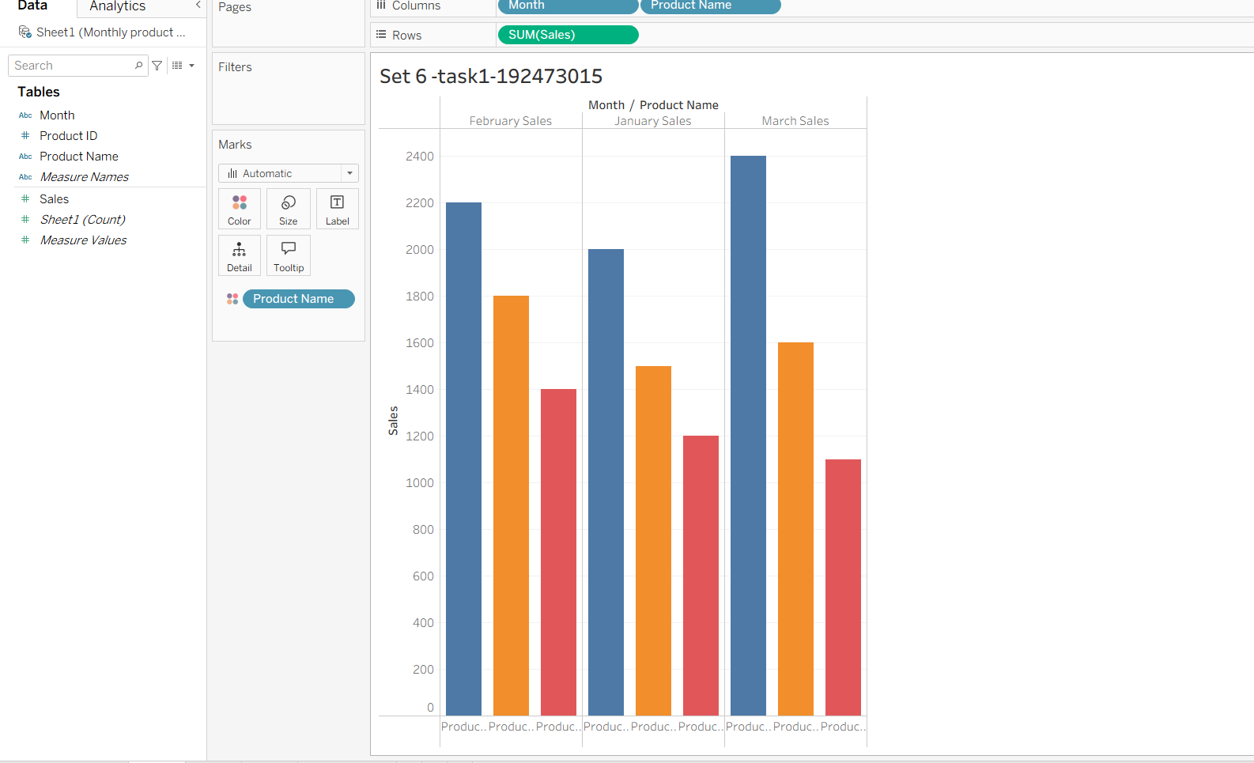
- Rename the title as Quarter 1 Product Sales.

Task 2: Stacked Area Chart
Procedure
- Open a New Worksheet.
- Drag Month to Columns.
- Drag Sales to Rows.
- Drag Product Name to Color.
- On the Marks card, select Area.
- Tableau creates a Stacked Area Chart.
- Rename the title as Overall Product Sales Trend.
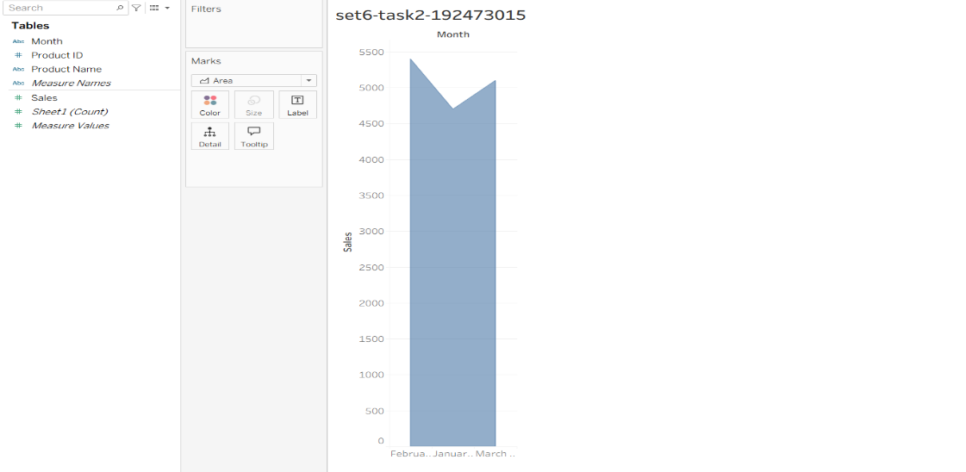

Task 3: Sales Table
Procedure
- Open a New Worksheet.
- Drag Product Name to Rows.
- Drag Month to Columns.
- Drag Sales to Text on the Marks card.
- Tableau displays the sales table.
- Rename the title as Monthly Product Sales Table.

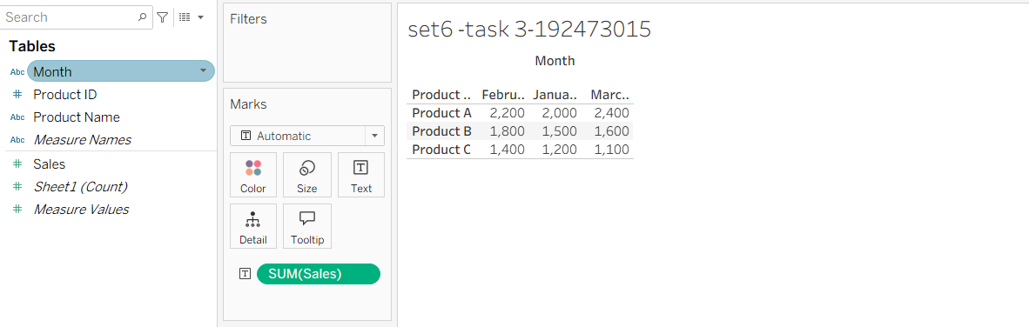

Task 4: Dashboard
Procedure
- Click New Dashboard.
- Drag the Grouped Bar Chart.
- Drag the Stacked Area Chart.
- Drag the Sales Table.
- Click the ▼ on the Bar Chart → Use as Filter.
- Show the dashboard title.
- Rename it as Product Sales Dashboard.
- Save the workbook.
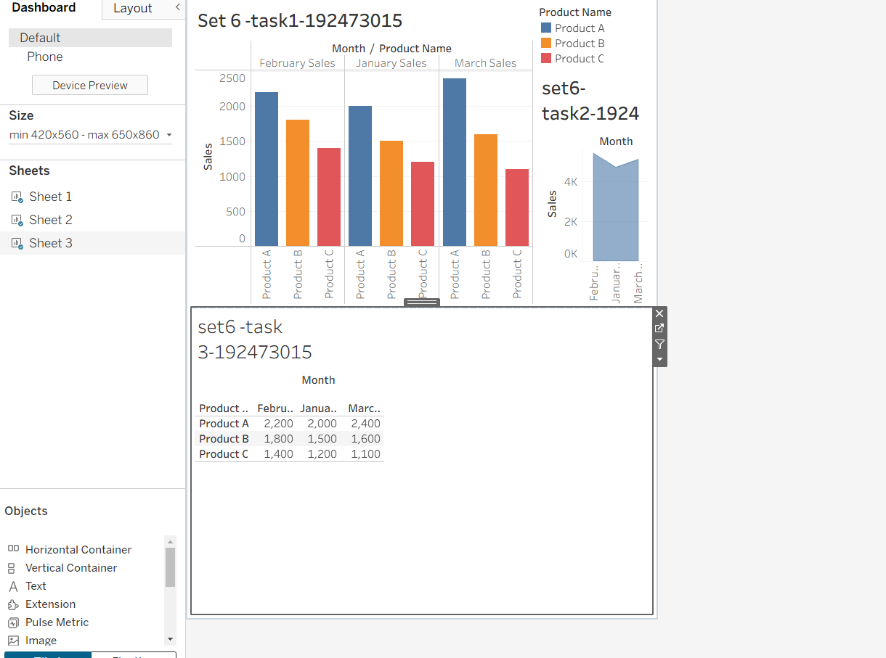

SET 7: Customer Demographics Analysis
Task 1: Bar Chart (Age Distribution)
Procedure
- Connect to the Customer Demographics dataset.
- Open Sheet 1.
- Drag Age to Columns.
- Drag Number of Records (or CNT(Customer ID) if Number of Records is unavailable) to Rows.
- Choose Bar Chart.
- Rename the title as Customer Age Distribution.
- Label the X-axis as Age.
- Label the Y-axis as Number of Customers.
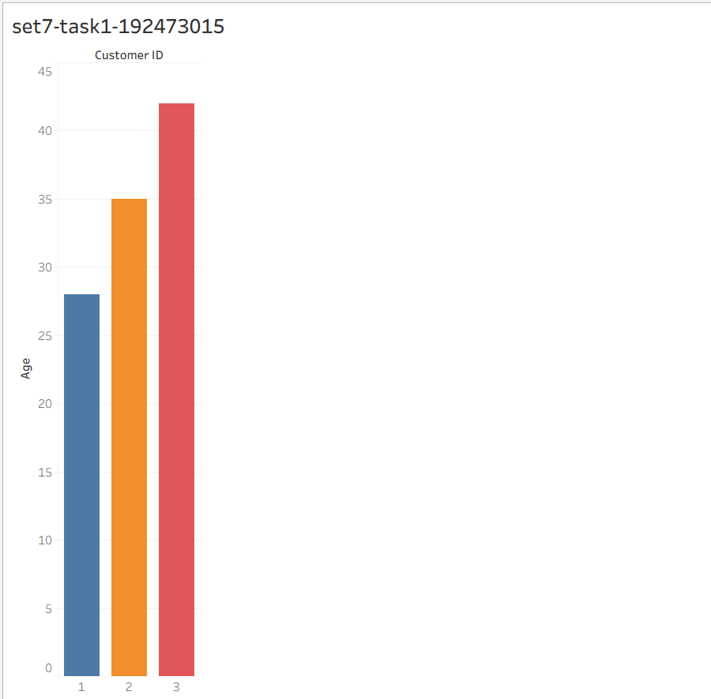

Task 2: Pie Chart (Gender Distribution)
Procedure
- Open a New Worksheet.
- Choose Pie Chart from Show Me.
- Drag Gender to Color.
- Drag Number of Records (or CNT(Customer ID)) to Angle.
- Drag Gender to Label.
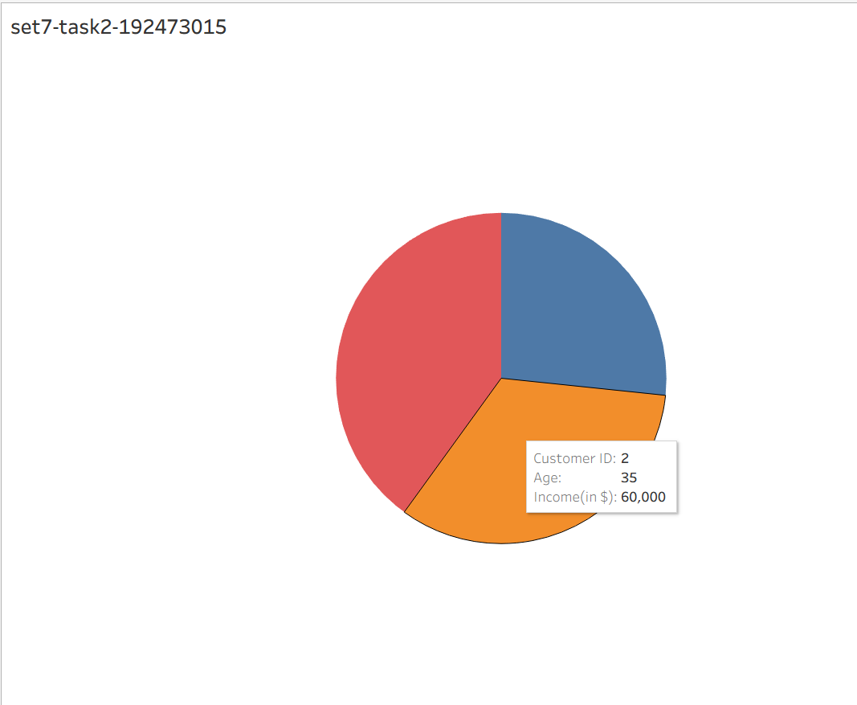
- Rename the title as Customer Gender Distribution.

Task 3: Demographic Table
Procedure
- Open a New Worksheet.
- Drag Customer ID to Rows.
- Drag Age, Gender, and Income to Text on the Marks card.
- Tableau displays the customer information table.
- Rename the title as Customer Demographic Information.

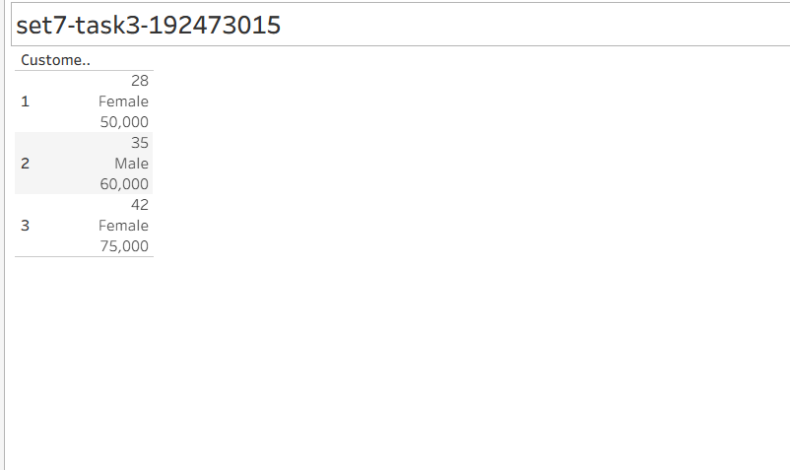

Task 4: Dashboard
Procedure
- Click New Dashboard.
- Drag the Bar Chart.
- Drag the Pie Chart.
- Drag the Demographic Table.
- Click the ▼ on the Bar Chart → Use as Filter.
- Show the dashboard title.
- Rename it as Customer Demographics Dashboard.
- Save the workbook.

